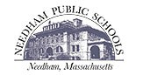
NEEDHAM HIGH SCHOOL
A Caring Community Striving for
Personal Growth and Academic Excellence

TO: Daniel Gutekanst, Superintendent
FROM: Aaron Sicotte, Principal
RE: NHS School Improvement Plan 2016-2019
DATE: 22 February 2017

The following Needham High School Improvement Plan (SIP) was developed during the fall of 2016 and winter of 2017 and was intended to build on the 2013-2016 SIP. As the plan states:

The purpose of this multi-year plan is to set the instructional and operational improvement agenda for the high school through June of 2019. This plan is closely aligned with the 2013-2016 SIP, and represents the next steps in the evolution of achievement for Needham High School. Consequently, the overarching objectives of this plan remain the same as the previous plan, while the action items represent new areas for student and institutional improvement and learning. The unifying aim of this plan is to foster and support the academic achievement and social-emotional growth of Needham High’s racially, ethnically, and socially diverse student community. It is with these objectives in mind that the NHS professional community will annually review this plan to assess the school’s performance in each area for improvement and to modify the plan as needed.

Attached please find the NHS School Improvement Plan for 2016-2019. I look forward to presenting a status report to the School Committee on February 28 regarding the goals outlined therein.

Thank you once again for your review and support of this document and the core beliefs and hard work that it represents. As always, please contact me should you have any questions or concerns.

609 WEBSTER ST. • NEEDHAM, MA 02494 • PHONE (781) 455-0800 • FAX (781) 449-5111

NEEDHAM HIGH SCHOOL
A Caring Community Striving for
Personal Growth and Academic Excellence

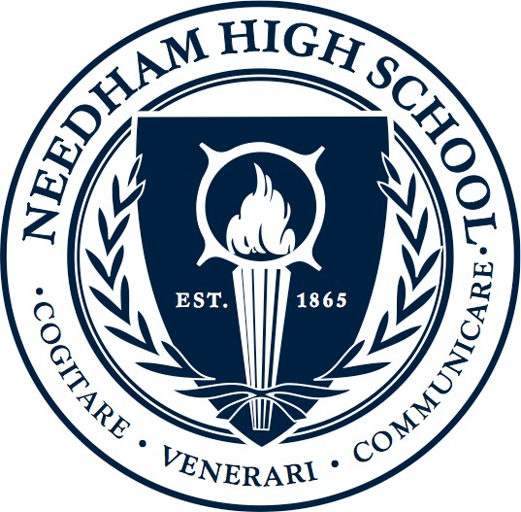

School Improvement Plan

SY 2016-2019

Needham High School
609 Webster Street
Needham, MA 02494

Page 1 of 7
Introduction
Development of the Needham High School Improvement Plan (SIP) for 2016-2019 has been a collaborative effort among all school constituencies, including the NHS School Council, the High School Cabinet, the Technology and Innovation Committee, the Interdisciplinary Learning Team, the Social Emotional Learning Committee, the NEASC Committee, the Faculty Council, and the Student Council. The primary focus of the goals within the SIP was to continue the long-standing efforts the NHS community has made in key areas. The SIP uses the district goals as a guide, adapting the broader goals into specific areas of focus within NHS. The document is meant to steer our work in essential areas over the three-year span, leaving room for the specific details to be developed by the groups directly involved. This plan readily reflects and supports the school’s core values: A Caring Community Striving for Personal Growth and Academic Excellence, and the work outlined herein will guide the entire school community in realizing this core belief.

The purpose of this multi-year plan is to set the instructional and operational improvement agenda for the high school through June of 2019. This plan is closely aligned with the 2013-2016 SIP, and represents the next steps in the evolution of achievement for Needham High School. Consequently, the overarching objectives of this plan remain the same as the previous plan, while the action items represent new areas for student and institutional improvement and learning. The unifying aim of this plan is to foster and support the academic achievement and social-emotional growth of Needham High’s racially, ethnically, and socially diverse student community. It is with these objectives in mind that the NHS professional community will annually review this plan to assess the school’s performance in each area for improvement and to modify the plan as needed. The three goals in the SIP are consistent with the district goals, ensuring cohesion between the work at Needham High School and that which is done at the district level. The three goals are: Advance Learning For All Students; Develop Social, Emotional, Wellness, and Citizenship Skills; and Ensure Infrastructure Supports District Values and Learning Goals.

Page 2 of 7

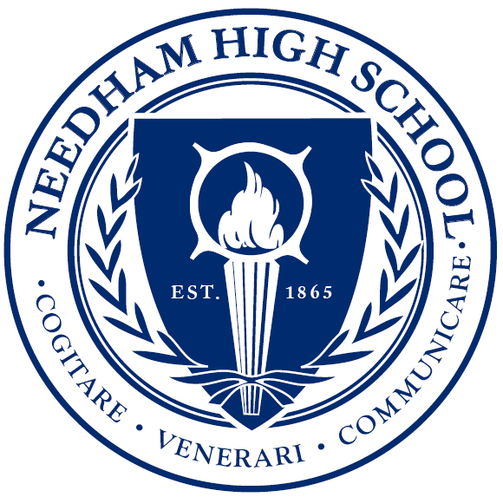
NEEDHAM HIGH SCHOOL
A Caring Community Striving for Personal Growth and Academic Excellence

Mission Statement

NEEDHAM HIGH SCHOOL DRAWS FROM THE STRENGTHS OF THE COMMUNITY TO CREATE TEACHING AND LEARNING PARTNERSHIPS BETWEEN FACULTY, PARENTS, AND STUDENTS, BOTH ON AN INDIVIDUAL LEVEL AND IN GROUPS, IN ORDER TO PROVIDE A HIGH QUALITY EDUCATION.

THE SCHOOL OFFERS STUDENTS A VARIETY OF OPPORTUNITIES TO EXCEL AND A DIVERSITY OF PERSPECTIVES FROM WHICH TO LEARN IN AN ENVIRONMENT THAT IS BOTH NURTURING AND CHALLENGING.

THE BALANCED STUDENT IS ABLE TO PARTICIPATE ACTIVELY IN SCHOOL AND SOCIETY, BE CREATIVE, AND SELF-ADVOCATE WHILE DETERMINING HIS OR HER UNIQUE PATH TO FULFILLMENT.

Page 3 of 7

Goal 1 – Advance learning for all students – To refine and continue to put into practice a system of curriculum, instruction,
and assessment that enables each student to be engaged in challenging, creative, and rigorous learning experiences that are
grounded in clearly defined standards.

ACTION ITEMS | DESCRIPTION | PROFESSIONAL ACTIVITIES | PERSON(S) RESPONSIBLE | IMPLEMENTATION | TARGET
- Interdisciplinary  Learning | Learning and instruction  that focuses on skills and  content that cross all  departmental areas  (example skills include  collaboration, problem  solving, creativity, etc.). | -Identify opportunities to  connect content across  subject areas  -Identify essential skills that  cross departments and  create rubrics for school-  wide use | -Interdisciplinary Learning  Specialist  -Interdisciplinary Learning  Team  -NEASC Committee | Fall 2016 – Spring 2019 | By the spring of 2019, NHS will  develop rubrics for identified  Interdisciplinary Learning skills  and begin to use the rubrics to  provide feedback to students.
- Technology  Integration | Using technology as a tool  to enhance student learning  and teachers’ instructional  options, particularly through  becoming 1 to 1 starting in  the fall of 2017. | -Provide professional  development on effective  integration of technology  - Research and visit other  schools that are 1 to 1 | -High School Cabinet  -Technology and Innovation  Committee  -Technology Integration  Specialists  -Director of Digital Learning | Fall 2016 – Spring 2019 | By the spring of 2019, NHS  will implement a 1 to 1  learning environment in every  class for two grades.
1.3 Senior Year | Creating a variety of options  that meet the range of  needs and interests seniors  have, such as internships,  projects, and online learning. | -Identify needs/interests of  seniors and create options to  for seniors to pursue,  beyond the traditional  path | -High School Cabinet  -Interdisciplinary Learning  Team  -Faculty Council  -School Council | Fall 2017 – Fall 2019 | By the fall of 2019, NHS will  offer students three alternate  options to the traditional  senior year experience.

Page 4 of 7

Goal 2 – Develop social, emotional, wellness and citizenship skills – To ensure students develop the knowledge and skills that
empower healthy, resilient, engaged and culturally proficient global citizens who act with integrity, respect, and compassion.

ACTION ITEMS | DESCRIPTION | PROFESSIONAL ACTIVITIES | PERSON(S) RESPONSIBLE | IMPLEMENTATION | TARGET
2.1 Cultural  Proficiency | Honoring the differences  between cultures, viewing  diversity as a benefit, and  interacting knowledgeably  and respectfully among a  variety of cultural groups. | -Create resources for staff to  embed culturally proficient  practices and strategies into  classrooms and exchanges  -Provide Cultural Proficiency  training for staff and  students to empower all to  create a strong, respectful  school environment | -Culture and Climate  Committee  -High School Cabinet  -Student Council | Fall 2016-Spring 2019 | Provide resources to staff  by the fall of 2017 to help  guide conversations and  build cultural proficiency  into classrooms.  By the spring of 2018, create  a multi-year plan to guide  the focus of work with staff  and students.
2.2 Social Emotional  Learning | Providing all students with  the skills and knowledge to  sustain their mental health  through resiliency and  mindfulness. | -Pilot a workshop geared to  building community and  teaching SEL skills, then  expand it for all 10th graders  -Create resources for staff to  use to teach SEL skills to –  and be able to support - all  students in each classroom | -Social Emotional Learning  Committee  -High School Cabinet  -Wellness Department  -Workshop Working Group | Fall 2017-Spring 2018 | In the spring of 2017, pilot  a workshop for 10th graders.  Transform the pilot into a  one-day workshop that each  10th grade student will  participate in.  By the spring of 2018, create  resources to build SEL skills  into all classrooms.
2.3 Digital Citizenship | Learning how to interact  appropriately and  respectfully in an online  environment, while leaving  a positive digital footprint  online and in the world. | -Use the NPS K-12 Digital  citizenship Curriculum to  teach all 9th grade students  digital citizenship skills  -Create teacher resources to  be used in classrooms and  adapted to content-specific  activities | -Technology Integration  Specialists  -Technology and Innovation  Committee  -Director of Digital  Learning  -High School Cabinet | Fall 2016-Spring 2018 | Finalize an online  curriculum that will be  taught in all freshmen  seminars, skills classes and  PLC beginning in the  fall of 2018.  Create resources and guides  for teachers to use in all  classrooms and content  areas.

Page 5 of 7

Goal 2 – Develop social, emotional, wellness and citizenship skills – To ensure students develop the knowledge and skills that
empower healthy, resilient, engaged and culturally proficient global citizens who act with integrity, respect, and compassion.

ACTION ITEMS | DESCRIPTION | PROFESSIONAL ACTIVITIES | PERSON(S) RESPONSIBLE | IMPLEMENTATION | TARGET
2.4 Restorative  Justice | Providing meaningful  opportunities to make  amends for and learn from  mistakes and inappropriate  behavior. | -Review discipline policies in  the Student Handbook and  propose changes for 2017.  -Include students more  directly in the disciplinary  process through restorative  circles and determining  appropriate restorative  justice responses  -Communicate the enhanced  practices to NHS community. | -Assistant Principals  -Principal  -NHS Student Council  -Guidance Department | Fall 2016-Spring 2018 | Update the NHS Student  Handbook in the spring of  2017 to explain restorative  justice practices.  In 2017-18, double the  number of restorative  circles used with  students.

Page 6 of 7

Goal 3 – Ensure infrastructure supports district values and learning goals – To develop, promote, and implement a sustain-
able plan for financial, building, technological, and human resources that supports learning for all and is responsive to school and
student needs.

ACTION ITEMS | DESCRIPTION | PROFESSIONAL ACTIVITIES | PERSON(S) RESPONSIBLE | IMPLEMENTATION | TARGET
3.1 Space Needs to  Address Rising  Enrollment | Defining the scope of the space  challenges at NHS and explore  options to address them. | -Work with the architects  to identify the space  needs and present to the  town a sustainable plan  to address the identified  school and student needs | -NHS Space Working  Group  -Principal  -School Committee | Fall 2016-Spring 2017 | By May of 2017, present  to the town a plan to  address the space needs  at NHS.
3.2 Assessing Our  Schedule | Determining NHS priorities and  needs for students and programs,  and determine a schedule to  best address those priorities and  needs. | -Explore schedule options  that meet the identified  needs, get feedback from stake-  holders, and decide on a  schedule that meets our  current needs or how to  meet those needs with  our current schedule | -Schedule Exploration  Committee  -High School Cabinet  -Student Council  -Needham Education  Association  -NHS Staff, Students, and  Parents | Fall 2016-Fall 2018 | For the fall of 2018,  decide on a schedule  that best meets our  students’ needs and  building priorities, and  implement it.
3.3 Safety Protocols | Refining and creating protocols that  make NHS as safe as possible and  practicing a range of drills to ensure  all NHS community members are as  prepared as possible. | -Create scenarios that  test varied intruder  situations that could  occur and practice them  bi-annually. | -Assistant Principals  -Principal  -Needham Police  Department | Fall 2016-Spring 2018 | By the spring of 2018,  create a schedule of two  safety drills each year,  with varied scenarios  and police involvement.

NHS School Council 2016-2017
Mary Bashir, Faculty
Scott Butchart, Parent
Jack Cruickshank, Class of 2018
Kathleen DeMayo, Parent
Jen Gould, Faculty
Michael Hirsh, Faculty
Jack Jahn, Class of 2020
Liam Nahill, Class of 2017
Chidinma Nwodo, Class of 2019
Matthew Saunders, Parent
Katherine Shannon, Class of 2019
Aaron Sicotte, Principal
Doug Stanczak, Faculty
Erica Supple, Parent
Aisha Tipnis, Class of 2019
Anne Weinstein, Parent

Page 7 of 7

Needham High School
Team Membership

2016-2017

Needham High School Cabinet
2016-2017

Joanne Allen Willoughby, Ph.D., K-12 Director, Metco

Johnny Cole, NHS Assistant Principal

Alison Coubrough-Argentieri, NHS Assistant Principal

Tom Denton, K-12 Director, Guidance

Keith Ford, NHS Assistant Principal

Patrick Gallagher, Chair, NHS English Department

Micah Hauben, 6-12 Director, Athletics

Patricia Mullen, Director, NHS Student Support Services

David Neves, Ed.D., K-12 Director, Fine & Performing Arts
Kathy Pinkham, Ed.D., K-12 Director, Wellness & P.E.
Stephen Plasko, Chair, NHS Social Studies Department

Jennifer Regrut, Chair, NHS Science Department

John Shea, Chair, NHS Mathematics Department

Aaron Sicotte, NHS Principal

Barbara Singer, K-12 Director, Student Health
Jean Tower, K-12 Director, Digital Media and Learning

Elizabeth Zajac, K-12 Director, World Languages

